**Assignment contains 5 Problems. Each problem is of 10 marks. Each problem contains sub tasks. Each task holds some points mentioned in the brackates out of 10. Requered images for Problem number 3, 4, 5 are present in provided folder named ‘Assets’.**

Problem 1:

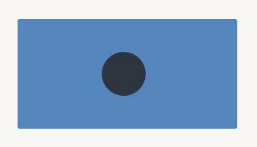

1. Create one Rectangle with HTML CSS with colour Blue(3)
2. Create one Circle with HTML CSS with Colour Black (3)
3. Align circle at the centre of the rectangle.(4)

Time: 30min

Problem 2:

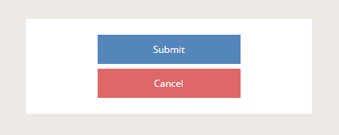

1. create one rectangle with colour white and border gray(2)
2. Add two buttons into it.(1)
3. Submit button should be green/blue(1)
4. Cancel button should be red(1)
5. Both buttons should be aligned at the middle of the Rectangle as shown.(5)

Time: 30 min

Problem 3:

Note: Images are in svg format. Present in Assets folder.

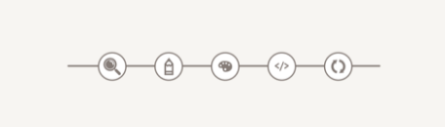

1. Create one line of 3px colour gray(1)
2. Create circles around the images as shown. Images must be of width 20px height 20px (4)
3. Position each image over the created line to create above image like structure (5)

Time: 1 hour

Problem 4:

Note: Assets folder contains few snapshots of problem number 4, 5 for reference.

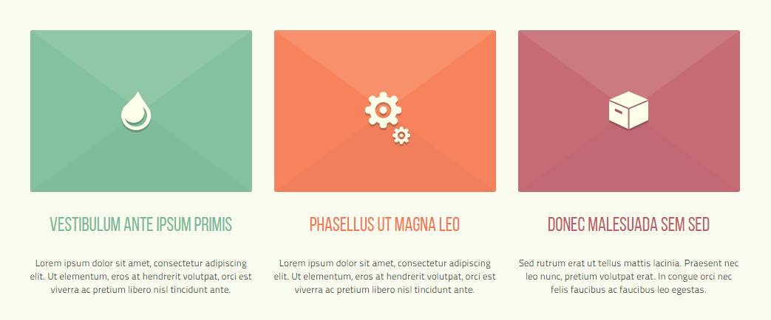

Note: Add any Random Text

1. Create a HTML CSS structure for rectangles as given in above image (4)
2. Get exact colours using paint or any other software(1)
3. Structure must be responsive and visible up to 320px screen width (3)
4. Images must be positioned at the centre of coloured boxes.(2)

Problem 5:

Note: Assets folder contains few snapshots of problem number 4, 5 for reference.

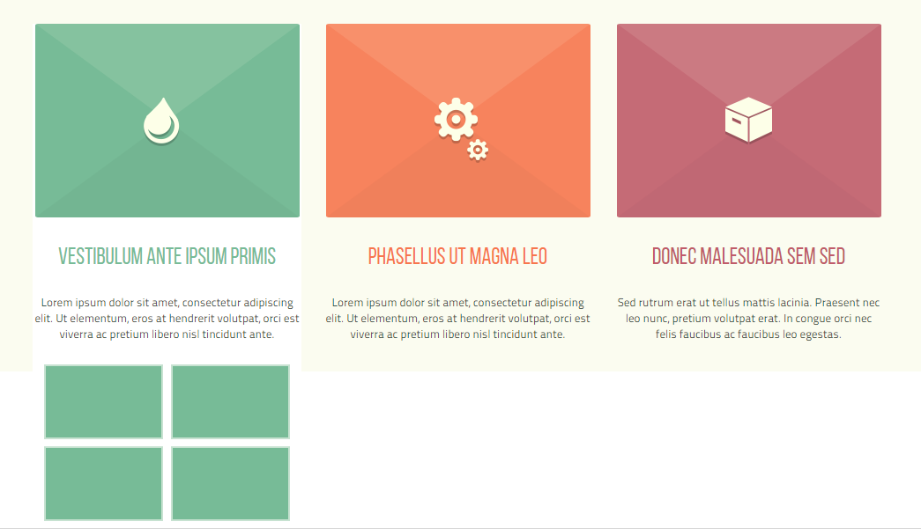

Note: This problem is continuation of problem number 4.

1. On Hover of Each box, Extra information should be shown as shown in image above(4)
2. This information should appear at the top of any other content(use position and z-index)(4)
3. On hover text background should become white as shown (2)